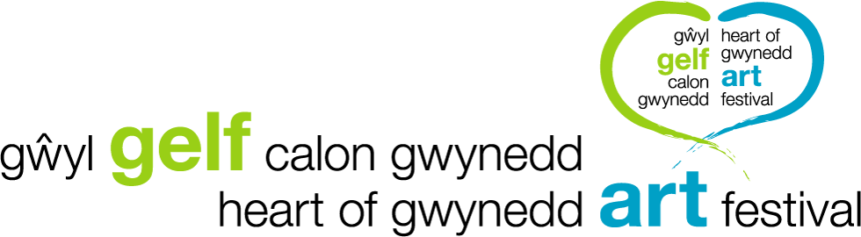 VENUE CODE;
Feedback - we rely on your feedback to help us make the festival even better and to give us a few statistics for funding applications for 2020.
Please would you take five minutes to fill in our feedback form on our website; either www.gwylgelfcalongwynedd.com or www.heartofgwyneddartfestival.co.uk
Gather these slips at each venue you visit and enter each different venue code on the online feedback form, each venue code will give you an entry in our raffle for a Stephen John Owen painting, kindly donated by the artist. There are seventeen venues so, potentially, seventeen entries.

VENUE CODE;
Feedback - we rely on your feedback to help us make the festival even better and to give us a few statistics for funding applications for 2020.
Please would you take five minutes to fill in our feedback form on our website; either www.gwylgelfcalongwynedd.com or www.heartofgwyneddartfestival.co.uk
Gather these slips at each venue you visit and enter each different venue code on the online feedback form, each venue code will give you an entry in our raffle for a Stephen John Owen painting, kindly donated by the artist. There are seventeen venues so, potentially, seventeen entries.

VENUE CODE;
Feedback - we rely on your feedback to help us make the festival even better and to give us a few statistics for funding applications for 2020.
Please would you take five minutes to fill in our feedback form on our website; either www.gwylgelfcalongwynedd.com or www.heartofgwyneddartfestival.co.uk
Gather these slips at each venue you visit and enter each different venue code on the online feedback form, each venue code will give you an entry in our raffle for a Stephen John Owen painting, kindly donated by the artist. There are seventeen venues so, potentially, seventeen entries.

